Build Snake and Ladder Game — LLD + Code — Complete Notes

Introduction
Low-level design of Snake and Ladder — similar structural pattern to the Tic Tac Toe LLD. Common interview question, especially for fresher-level interviews. Game rules change, but the overall design architecture (top-down approach) remains the same.

Functional Requirements
# | Requirement
1 | Board size should be scalable — 100 cells (standard), 1000, or n×n
2 | Standard game rules — extensible for custom rules
3 | Game setup strategies — must support multiple ways to place snakes and ladders: Standard setup, Custom setup, Random setup
4 | On-app notifications — when a move happens or a player wins, in-app notifications appear (like online Ludo/Chess)

Setup Strategies — Detailed
Standard Setup: The classic board positions where snakes and ladders are pre-defined (from real Snake & Ladder games). Fixed configuration.
Custom Setup: User specifies:
- How many snakes and how many ladders they want
- Optionally, exact start/end positions for each snake and ladder
Random Setup: System distributes snakes and ladders randomly. Further classified by difficulty:
Difficulty | Snake vs Ladder Ratio
Easy | Fewer snakes, more ladders
Medium | Equal snakes and ladders
Hard | More snakes, fewer ladders

Key Design Insight — Board Representation
Critical point: A Snake & Ladder board is visually shown as 2D, but is actually a 1D array (cells 1 to n).
Further simplification: You don't even need a 1D array. Because:
- Cells are just numbered 1 to n
- You only need to know which cells have snakes/ladders
- Player's own position is stored inside the Player object
Solution: Use a Map<Integer, BoardEntity> — maps cell number → snake/ladder entity at that cell.
Why the map (O(1) lookup):
- To find if a cell has a snake or ladder, check map.get(cellNumber)
- Avoids looping through a list of entities each time
- Major performance benefit

Design Approach — Top-Down
Same as Tic Tac Toe: design big objects first, then decompose into smaller objects.
Order:
- Game (biggest orchestrator)
- Board (from Game)
- BoardEntity → Snake/Ladder (from Board)
- SetupStrategy → Standard/Random/Custom (from Board)
- Dice (from Game)
- Player (from Game)
- Rule → StandardRule (from Game)
- IObserver → ConsoleNotifier (for notifications)
- GameFactory (factory)

Class-by-Class Design

1. Game Class (Orchestrator / Main)

Fields
Field | Type | Purpose
board | Board | The game board
dice | Dice | The dice used to roll
players | Deque<Player> | Players in turn order
rules | Rule | Rule strategy (Standard Rule for now)
observers | List<IObserver> | Notification observers
gameOver | boolean | Whether game ended

Methods
Method | Purpose
addPlayer(Player) | Add player to deque
addObserver(IObserver) | Add notification observer
notifyAll(message) | Broadcast message to all observers
displayPlayerPosition(player) | Show player's current position
play() | Main game loop

2. Board Class

Fields
Field | Type | Purpose
size | int | Total cells in board (e.g., 100)
entities | List<BoardEntity> | List of all snakes and ladders
entityMap | Map<int, BoardEntity> | Cell number → entity at that cell (O(1) lookup)

Why Two Structures (List + Map)
- List: For iterating all entities (e.g., display, count, validation)
- Map: For fast lookup "is there an entity at cell 25?"
- No 1D array needed — cell numbers are implicit from size

Methods
Method | Purpose
addEntity(BoardEntity e) | Add entity to list + map (at e.start)
canAddEntity(int position) | Check if entity can be placed at position
getEntity(int position) | Return entity at cell (or null)
setupBoard(SetupStrategy strategy) | Delegate board setup to strategy
display() | Print board, snakes, ladders
getBoardSize() | Getter
Important: Board is a "dumb object" — it only manages its entities. It does NOT know game rules (who wins, how snake/ladder move works). SRP-driven separation.

3. BoardEntity (Abstract Parent) — Snake & Ladder
Design rationale: Snake and Ladder both do the same thing — move a player from one cell to another. Snake moves down, Ladder moves up. Structurally identical.
Instead of separate Snake and Ladder classes, use a parent abstraction BoardEntity:

BoardEntity (Abstract)
Field | Type | Purpose
start | int | Starting cell
end | int | Ending cell

Method | Purpose
getName() | Returns "Snake" or "Ladder" (abstract)
display() | Print representation (abstract)

Snake (Concrete)
- start > end (head higher, tail lower)
- Validation in constructor: if end >= start → print "Invalid Snake" (end must be less than start)
- getName() returns "Snake"
- display() prints "Snake: start → end"

Ladder (Concrete)
- end > start (top higher, bottom lower)
- Validation in constructor: if end <= start → print "Invalid Ladder" (end must be greater than start)
- getName() returns "Ladder"
- display() prints "Ladder: start → end"

Relationship
- Board has-a 1..many BoardEntity (composition — entities don't exist without board)
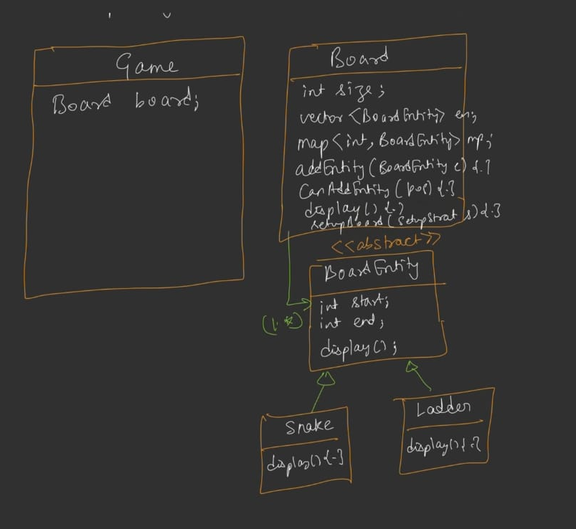

7. SetupStrategy (Abstract Strategy)

Methods (Abstract)
Method | Purpose
setupBoard(Board board) | Populate the board with snakes and ladders

Concrete Strategies

7a. StandardSetupStrategy
- Places snakes and ladders at pre-defined positions (from real Snake & Ladder games)
- Only works for 10×10 (100-cell) boards
- If board size ≠ 100 → print "Standard setup only works for 10×10" and return
- Uses standard snake positions (e.g., start 99 → end 54, start 95 → end 75, etc.) and ladder positions
- Positions taken from real Snake & Ladder board (common reference)

7b. RandomSetupStrategy
Nested Enum: Difficulty { EASY, MEDIUM, HARD }
Constructor takes a Difficulty level:
- EASY: fewer snakes, more ladders (e.g., 30% snakes, 70% ladders)
- MEDIUM: equal snakes and ladders (50%/50%)
- HARD: more snakes, fewer ladders (e.g., 70% snakes, 30% ladders)
setupBoard(Board) logic:
- Switch on difficulty
- Call private setupWithProbability(board, snakeProbability):
  - totalEntities = boardSize / 10 (heuristic — 10% of cells have entities)
  - For each iteration:
    - prob = random() / RAND_MAX
    - If prob < snakeProbability → try to add a snake (random start > end)
    - Else → try to add a ladder (random start < end)
  - Retry mechanism: Each entity add attempt runs in a while (attempt < 50) loop — retries up to 50 times because canAddEntity may return false (position already occupied)
  - 50 chosen because it's large enough to eventually place the entity in most cases
Random position generation:
- Snake: start = random(2, boardSize), end = random(1, start-1)
- Ladder: start = random(1, boardSize-1), end = random(start+1, boardSize)

7c. CustomSetupStrategy
Constructor parameters:
Param | Type | Purpose
numberOfSnakes | int | How many snakes
numberOfLadders | int | How many ladders
isRandom | boolean | Are positions random?
snakePositions | List<Pair<start, end>> | Exact snake positions (if isRandom=false)
ladderPositions | List<Pair<start, end>> | Exact ladder positions (if isRandom=false)
Helper Methods:
- addSnakePosition(start, end) — append to snakePositions list
- addLadderPosition(start, end) — append to ladderPositions list
setupBoard(Board) logic:
If isRandom == true:
- Loop until numberOfSnakes added:
  - Generate random start/end; try to add (retry up to 50 times if needed)
- Loop until numberOfLadders added:
  - Same approach
If isRandom == false:
- Iterate snakePositions list → for each (start, end) pair, add Snake
- Iterate ladderPositions list → for each (start, end) pair, add Ladder
Notes on custom add methods: User only provides start/end values, not Snake/Ladder objects. The strategy internally creates the Snake/Ladder objects (encapsulation).
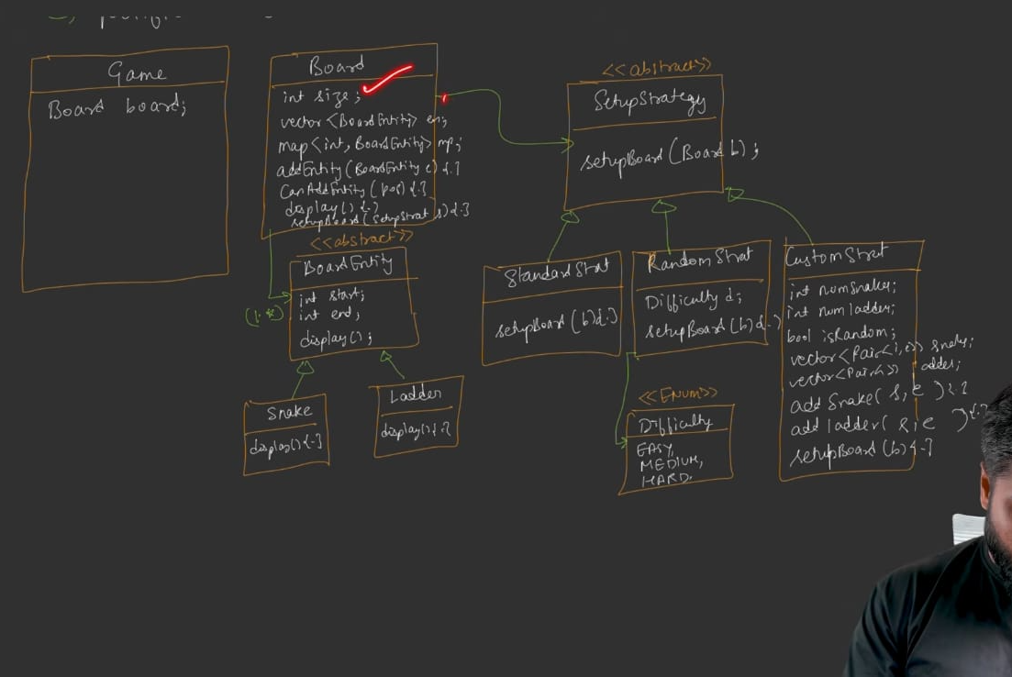

4. Dice Class

Fields
Field | Type | Purpose
faces | int | Number of faces (default 6)

Methods
Method | Purpose
roll() | Returns random value between 1 and faces (inclusive)
Implementation: random() % faces + 1 → gives 1 to faces
Scalability: faces is configurable — 6 (standard), 10, 20, etc.

5. Player Class

Fields
Field | Type | Purpose
playerId | String | Unique ID
name | String | Player name
position | int | Current cell position (0 initially)
score | int | Cumulative score across games

Methods
Method | Purpose
Getters/Setters | Access all fields
incrementScore() | Score++
Relationship: Game has-a 1..many Player (Deque-based rotation)
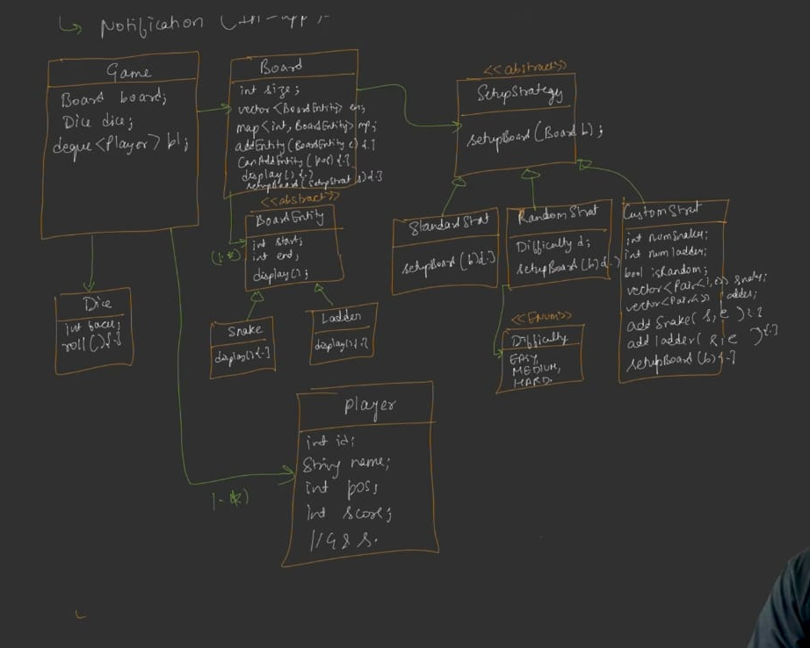

6. Rule Class (Abstract Strategy)

Methods (Abstract)
Method | Signature | Purpose
isValidMove(position, diceValue, boardSize) | Returns boolean | Is the move valid?
calculateNewPosition(position, diceValue, board) | Returns int | New position after snake/ladder
checkWinCondition(position, boardSize) | Returns boolean | Has this player won?
No checkDraw — Snake & Ladder has no draw; someone always wins.

StandardRule (Concrete)
Implements standard Snake & Ladder rules:
isValidMove(pos, diceValue, boardSize):
- Valid iff pos + diceValue <= boardSize
- Example: boardSize=100, pos=98, diceValue=4 → 98+4=102 > 100 → invalid
- Player must land exactly on the last cell (needs to roll 2 in this case)
- If not valid, player rolls again next turn
calculateNewPosition(pos, diceValue, board):
- intermediatePos = pos + diceValue
- Check board.getEntity(intermediatePos):
  - If null → newPos = intermediatePos
  - If snake → newPos = entity.end (go down)
  - If ladder → newPos = entity.end (go up)
- Return newPos
checkWinCondition(pos, boardSize):
- Return pos == boardSize
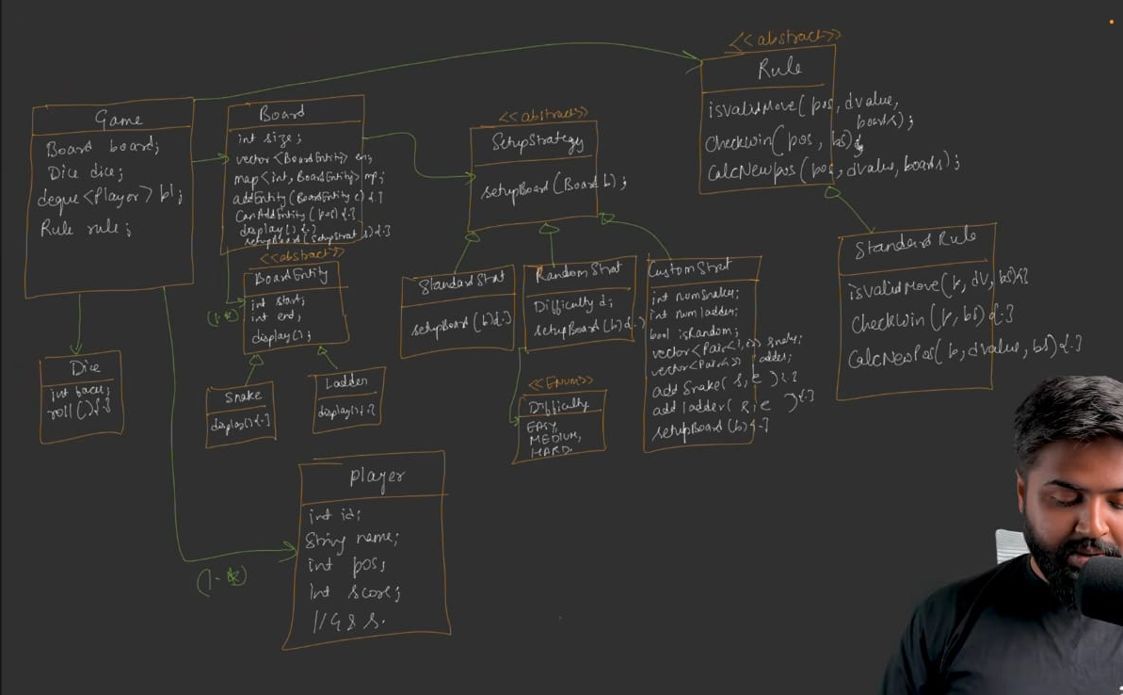

8. Observer Pattern — Notifications
Same pattern as Tic Tac Toe:

IObserver (Abstract)
- update(String message) — receives notification

ConsoleNotifier (Concrete)
- Implements update — prints "Notification: <message>" to console

Game as Observable
- Game holds List<IObserver> observers
- addObserver(o) — add to list
- notifyAll(message) — iterate observers, call update(message) on each
Notification triggers:
- Game started
- Player rolled dice / made move
- Player landed on snake
- Player landed on ladder
- Player won
Extensibility: Can add EmailNotifier, SMSNotifier, LoggerObserver — just implement IObserver.
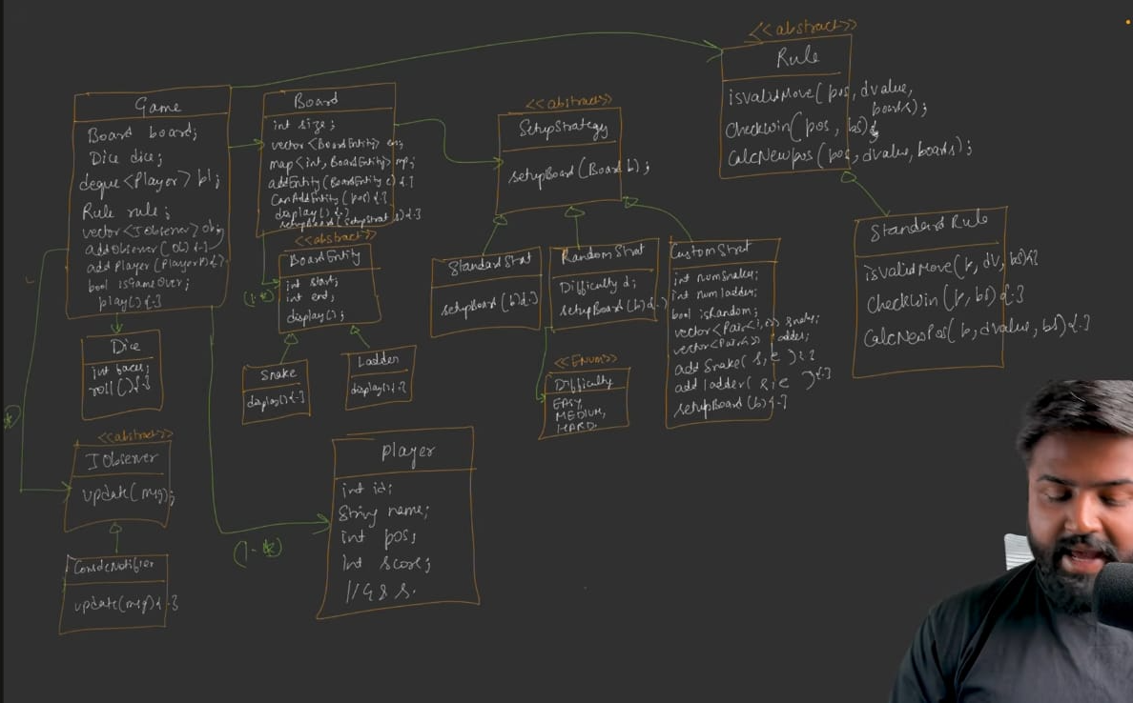

9. GameFactory

Methods
Method | Purpose
createStandardGame(int boardSize) | Create standard game (10×10 board, standard setup, 6-face dice)
createRandomGame(int boardSize, Difficulty level) | Create random game with difficulty
createCustomGame(int boardSize, SetupStrategy customStrategy) | Create custom game with user-defined strategy
Template approach: Each factory method internally:
- Creates board
- Sets up board using the appropriate setup strategy
- Creates dice (6 faces)
- Creates game with board + dice
- Returns game object
Benefit: Client calls one factory method and gets a fully-initialized game — no need to know internal construction details.
Final UML:-
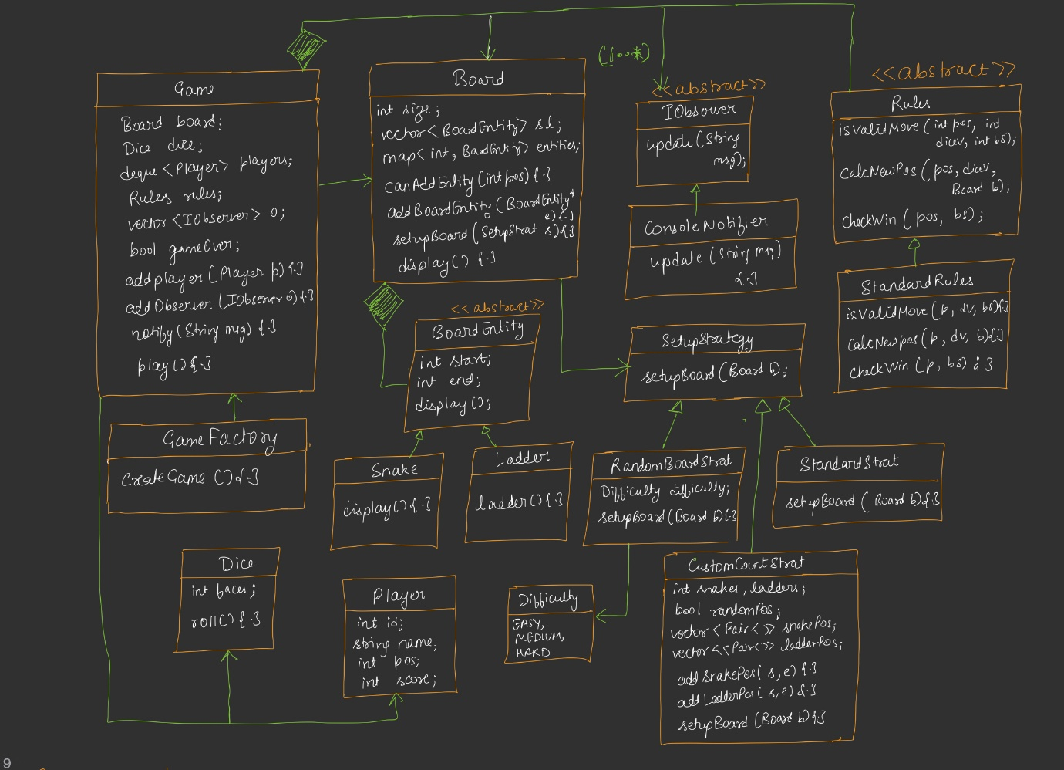

UML Relationships Summary
Relationship | Type | Details
Game has-a Board | Composition | Board lifetime tied to Game
Game has-a Dice | Composition | —
Game has-a Rule | Composition | Rules can't exist without game
Game has-a List<Player> | 1..many | Deque for turn rotation
Game has-a List<IObserver> | 1..many | Observer pattern
Board has-a List<BoardEntity> | 1..many | Composition
Board has-a Map<int, BoardEntity> | — | Fast lookup
BoardEntity ← Snake, Ladder | Inheritance | Abstract parent
Rule ← StandardRule | Strategy (inheritance) | —
SetupStrategy ← Standard, Random, Custom | Strategy (inheritance) | —
IObserver ← ConsoleNotifier | Inheritance | —
GameFactory creates Game | Factory | —
Strong composition relationships:
- Game → Rule (rules don't exist independently)
- Board → BoardEntity (snakes/ladders don't exist without the board)

Gameplay Flow (play() method)
text
Client → Game.play()
│
├─ Validate: at least 2 players (else exit)
├─ notifyAll("Game Started")
├─ board.display()
│
├─ while (!gameOver):
│ ├─ currentPlayer = players.pollFirst()
│ │
│ ├─ Prompt: "<name>, press Enter to roll the dice"
│ ├─ diceValue = dice.roll()
│ │
│ ├─ currentPos = currentPlayer.position
│ │
│ ├─ if (rules.isValidMove(currentPos, diceValue, boardSize)):
│ │ ├─ intermediatePos = currentPos + diceValue
│ │ ├─ newPos = rules.calculateNewPosition(currentPos, diceValue, board)
│ │ ├─ currentPlayer.position = newPos
│ │ │
│ │ ├─ entity = board.getEntity(intermediatePos)
│ │ ├─ if entity != null:
│ │ │ ├─ if entity.name == "Snake" → notifyAll("Snake encountered")
│ │ │ └─ if entity.name == "Ladder" → notifyAll("Ladder used")
│ │ │
│ │ ├─ notifyAll("<name> played, position updated")
│ │ ├─ board.display()
│ │ │
│ │ ├─ if rules.checkWinCondition(newPos, boardSize):
│ │ │ ├─ print("<name> wins! Game ended")
│ │ │ ├─ currentPlayer.incrementScore()
│ │ │ ├─ notifyAll("Winner: <name>")
│ │ │ └─ gameOver = true
│ │ │
│ │ └─ else: players.addLast(currentPlayer) // rotate
│ │
│ └─ else:
│ ├─ print("Exact roll needed to reach end")
│ └─ players.addLast(currentPlayer) // rotate anyway
│
└─ End loop

Notes
- Dice rolling is user-triggered in the demo (cin.ignore() + wait for Enter) — in real apps it's automatic
- Retry mechanism: If move invalid (e.g., overshooting end), player doesn't move but rotates to back of queue; their next turn they can try again
- Notifications sent at various points (move, snake, ladder, win)
- Rotation: pollFirst() then addLast() — cyclic turn order
Code … see Notes

Code — Key Highlights

Board Key Logic
canAddEntity(position):
java
return entityMap.find(position) == entityMap.end();
- Returns true if no entity currently at that cell
addEntity(BoardEntity e):
java
if (canAddEntity(e.getStart())) {
entities.push_back(e);
entityMap[e.getStart()] = e;
}
- Adds to list AND map (map key = start position, since that's where snake head / ladder bottom is)
getEntity(position):
java
if (entityMap.find(position) != entityMap.end())
return entityMap[position];
return null;
setupBoard(SetupStrategy strategy):
java
strategy.setupBoard(*this); // pass this board

StandardRule Key Logic
isValidMove:
java
return position + diceValue <= boardSize;
calculateNewPosition:
java
int newPos = position + diceValue;
BoardEntity entity = board.getEntity(newPos);
if (entity != null) return entity.getEnd();
return newPos;
checkWinCondition:
java
return position == boardSize;

RandomSetupStrategy Probability Logic
java
switch (difficulty) {
case EASY: setupWithProbability(board, 0.3); break; // 30% snakes
case MEDIUM: setupWithProbability(board, 0.5); break; // 50% snakes
case HARD: setupWithProbability(board, 0.7); break; // 70% snakes
}
setupWithProbability:
java
int totalEntities = board.getBoardSize() / 10;
for (int i = 0; i < totalEntities; i++) {
double prob = rand() / RAND_MAX;
if (prob < snakeProbability) {
// Add snake with retry
int attempts = 0;
while (attempts < 50) {
int start = random(2, boardSize);
int end = random(1, start - 1);
if (board.canAddEntity(start)) {
board.addEntity(new Snake(start, end));
break;
}
attempts++;
}
} else {
// Add ladder with retry (similar)
}
}

CustomSetupStrategy Key
Two modes:
- Random mode: Uses numberOfSnakes and numberOfLadders; generates random positions internally
- Exact mode: Uses snakePositions and ladderPositions vectors (user-provided start/end pairs); places them exactly

GameFactory Methods
createStandardGame:
java
Board board = new Board(10 * 10); // 100 cells
SetupStrategy strategy = new StandardSetupStrategy();
board.setupBoard(strategy);
Dice dice = new Dice(6);
return new Game(board, dice);
createRandomGame:
java
Board board = new Board(boardSize);
SetupStrategy strategy = new RandomSetupStrategy(difficulty);
board.setupBoard(strategy);
Dice dice = new Dice(6);
return new Game(board, dice);
createCustomGame:
java
Board board = new Board(boardSize);
board.setupBoard(customStrategy);
Dice dice = new Dice(6);
return new Game(board, dice);

Main Method — Game Setup Flow
java
// 1. Ask user: Standard / Random / Custom
int choice = userInput();

Game* game = nullptr;
Board* board = nullptr;

if (choice == STANDARD) {
game = GameFactory::createStandardGame();
board = new Board(10 * 10);
}
else if (choice == RANDOM) {
// Ask: EASY / MEDIUM / HARD
int difficulty = userInput();
// Create RandomSetupStrategy with difficulty
game = GameFactory::createRandomGame(boardSize, difficulty);
board = new Board(boardSize);
}
else if (choice == CUSTOM) {
// Ask: board size
// Ask: number of snakes, number of ladders
// Ask: random positions or exact positions?
if (exact positions) {
// Loop to collect start/end for each snake/ladder
// Call strategy.addSnakePosition(start, end) / addLadderPosition(start, end)
}
game = GameFactory::createCustomGame(boardSize, strategy);
board = new Board(boardSize);
}
else {
print("Invalid choice");
return;
}

// Validate game creation
if (game == nullptr) {
print("Something went wrong");
return;
}

// Add observer
game->addObserver(new SnakeAndLadderConsoleNotifier());

// Get player count and names
int playerCount = userInput();
for (int i = 0; i < playerCount; i++) {
String name = userInput();
Player* p = new Player(..., name);
game->addPlayer(p);
}

// Start game
game->play();

Sample Test Output (Standard Game)
text
Do you want to play:
1. Standard Game
2. Random Game
3. Custom Game
> 1

Enter number of players: 2
Enter player 1 name: Aditya
Enter player 2 name: Harshita

Board configured:
Cells: 100
Snakes placed:
- Snake from 99 to 54
- Snake from 95 to 75
- ... (10 snakes total)
Ladders placed:
- Ladder from 4 to 25
- ... (11 ladders total)

Aditya's turn. Press Enter to roll dice.
> [Enter]
Dice rolled: 1
Aditya's new position: 1

Harshita's turn. Press Enter to roll dice.
> [Enter]
Dice rolled: 4
Harshita's new position: 4

... (game continues) ...

Aditya reached 100!
Aditya wins! Game ended. Winner is Aditya.
Gameplay observations:
- Player can be sent down by snakes multiple times
- Player must land exactly on cell 100 (e.g., if at 98, needs 2)
- Invalid overshoot → player rotates to next turn (doesn't move)

Design Patterns Used
Pattern | Where | Purpose
Strategy | Rule (StandardRule); SetupStrategy (Standard, Random, Custom) | Interchangeable rules and setup algorithms
Observer | IObserver, ConsoleNotifier; Game as Observable | In-app notifications
Factory | GameFactory | Centralized game creation with template methods
Composition | Game→Board, Game→Rule, Board→BoardEntity | Strong ownership
SRP | Board doesn't know rules; Rules don't know board internals; SetupStrategy encapsulates setup | Each class has one reason to change
Design trade-offs:
- Board is a "dumb object" — doesn't know game rules. Follows SRP strictly.
- Game is orchestrator — breaks SRP by nature (it delegates), but that's inherent to orchestrators
- StandardSetupStrategy hardcodes 10×10 requirement — makes it less flexible but reflects real-game constraints

Extensibility Suggestions
- Add custom rules: Extend Rule → e.g., "snake 99 → end 0 means restart", "ladder can also act as snake based on dice"
- Add more setup strategies: e.g., "symmetric setup", "themed setup"
- Add more dice types: Already parameterized by faces; just create with different faces count
- Add more observers: Email/SMS notifiers for production use
- Multiple games in one session: Track scores across games (Player.score already there)
- Save/Load game state: Serialize board + player positions

One-Line Summary per Class
Class | One-Line Summary
Game | Orchestrator — owns Board, Dice, Players, Rules, Observers; main play() loop
Board | Manages cells implicitly via size + entity map/list; doesn't know game rules
BoardEntity | Abstract parent for Snake and Ladder — both move a player from start to end
Snake | Concrete entity (start > end) — player falls down
Ladder | Concrete entity (end > start) — player climbs up
Dice | Rolls a random value 1..faces
Player | Player identity + position + score
Rule | Abstract strategy — isValidMove, calculateNewPosition, checkWinCondition
StandardRule | Standard Snake & Ladder rules
SetupStrategy | Abstract strategy — setupBoard(Board)
StandardSetupStrategy | Fixed classic positions (10×10 only)
RandomSetupStrategy | Random placement with Difficulty (Easy/Medium/Hard)
CustomSetupStrategy | User-defined positions or counts
IObserver | Abstract observer — update(message)
ConsoleNotifier | Prints notifications to console
GameFactory | Creates Standard/Random/Custom games (template methods)

Quick Verification Checklist
- □
Board size scalable (100, 1000, custom)
- □
Setup strategy supports Standard, Random (Easy/Medium/Hard), Custom
- □
Board uses Map (not 2D matrix) for O(1) entity lookup
- □
BoardEntity abstracts Snake and Ladder
- □
Snake validation: start > end
- □
Ladder validation: end > start
- □
Dice configurable faces (default 6)
- □
Deque<Player> for turn rotation
- □
Rule validates move (pos + dice ≤ boardSize)
- □
Rule calculates new position (handles snake/ladder redirection)
- □
Rule checks win (position == boardSize)
- □
Observer pattern for notifications
- □
Factory creates games with template methods
- □
Composition: Game→Rule, Board→BoardEntity
- □
Invalid move → player rotates, doesn't move
- □
Player must land exactly on last cell

